Demandware: Automated Emails

1. Welcome email on successful registration
2. Email product to a friend
3. Email wish list to a friend
4. Order confirmation email
5. Order despatched/unable to fulfil email
6. Order cancellation email
7. Order returned email
8. Forgot password email
9. New password confirmation email (after password reset)
10. Email with purchased e-gift card details
11. Email with returned e-gift card details

1. Welcome email on successful registration🡪 Email Template: newAccount

Subject line: You’ve successfully registered at Seafolly

1). ‘newsletter-header’ – Contains logo

Imagen que contiene objeto

Descripción generada con confianza alta

2). ‘[newaccount-newsletter-body](https://dev05-shop-avenue32.demandware.net/on/demandware.store/Sites-Site/default/ViewLibraryContent_52-Start?ContentUUID=bcFJaiaaiuH46aaadnHXAmgK6p)’

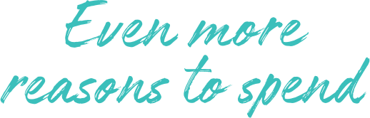

Hi [First Name], congratulations on creating your Maaji - Mermaid account!

You now get to enjoy all the benefits of beign a registered customer.

* Suscribe and get a $20 voucher on your birthday month.
* Receive news about exclusive offers and products.
* Save your order history.
* Speed up the checkout by storing billing & shipping info.

**

*Included four category static images, name and link*

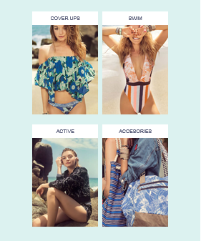

3). emailComponent - ‘newsletter-footer’ 🡪 Content Asset – ‘newsletter-footer’

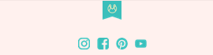

Email Template structure:

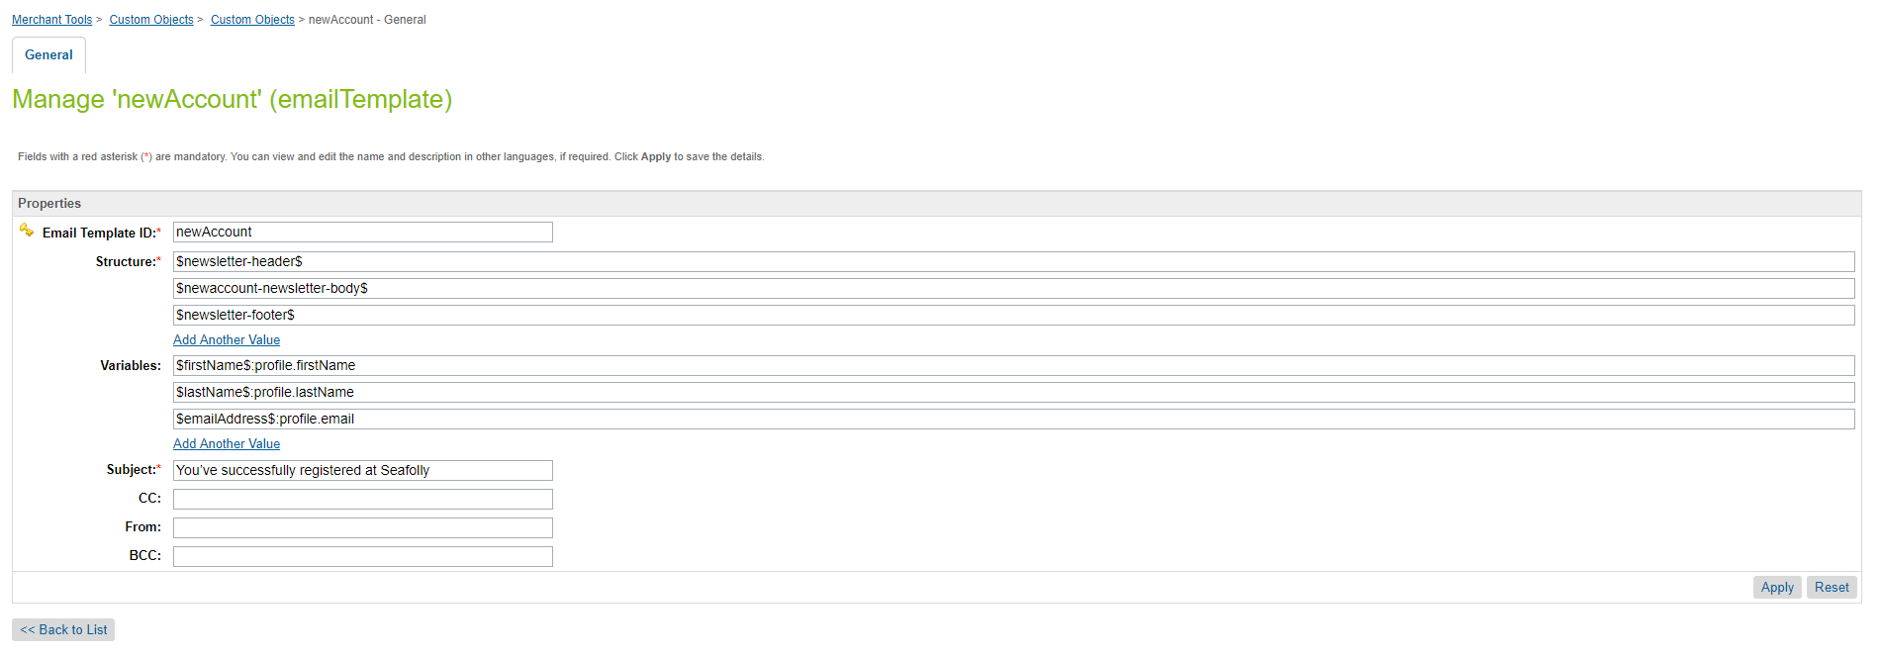

Email component:

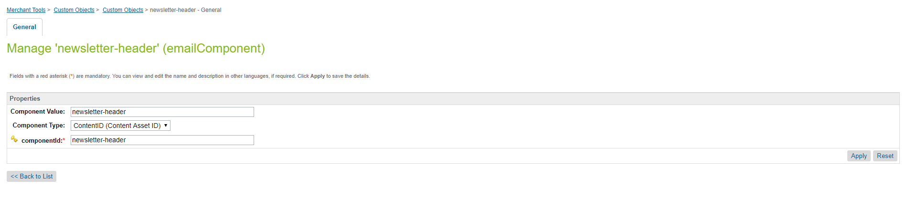

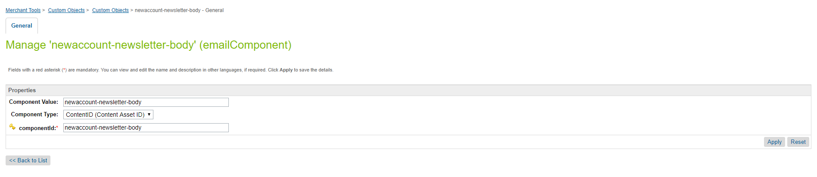

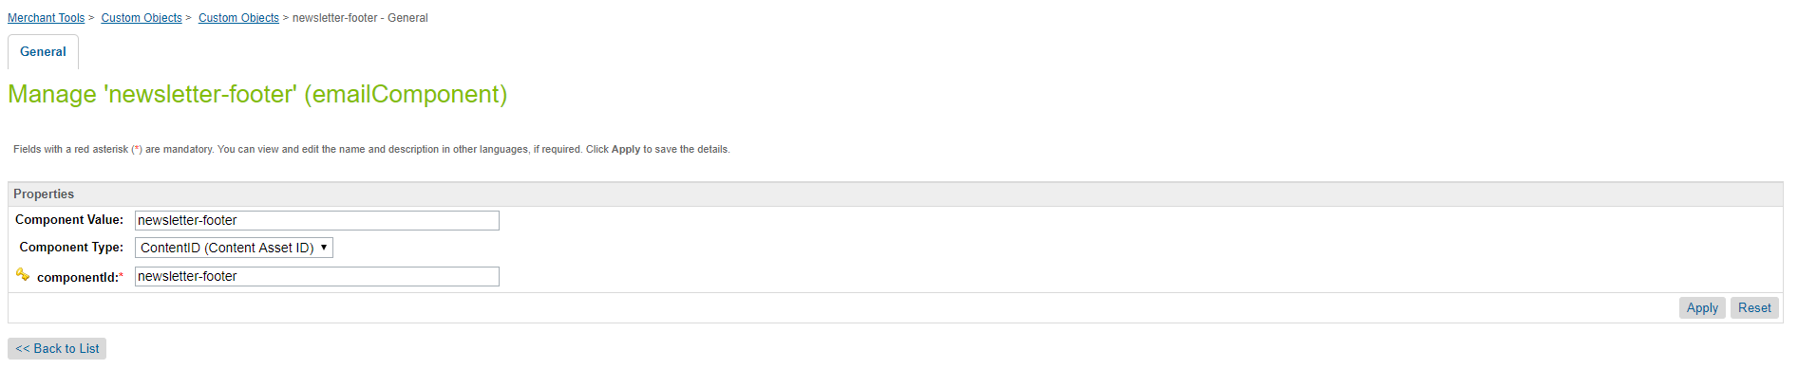

2. Email product to a friend🡪 Email Template: sendToFriend

Subject line: [NAME] has sent you a style suggestion from Seafolly

1). ‘newsletter-header’ – Contains logo

Imagen que contiene objeto

Descripción generada con confianza alta

2). ‘send-to-friend-body-customer-msg’



From: [Friend’s Name]

[Sender’s Email]

[Sender’s Message]

3). Custom object emailComponent: ‘send-to-friend-body-product-info’

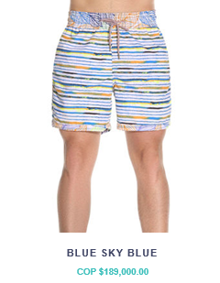



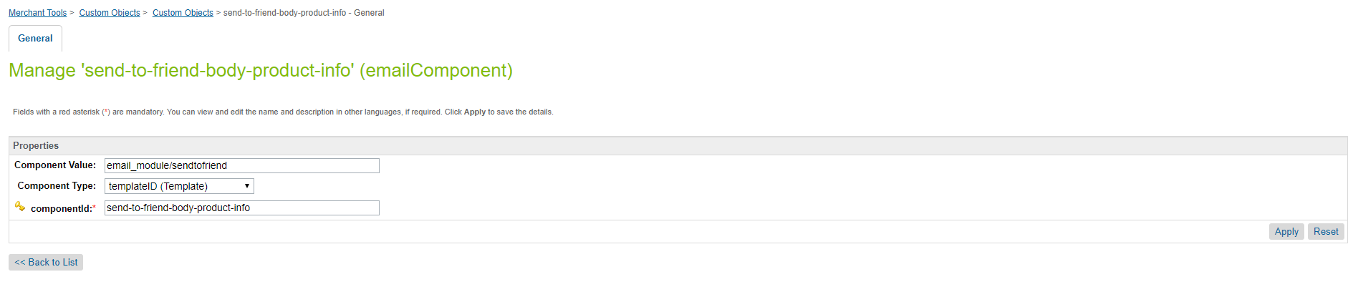

4). emailComponent - ‘newsletter-footer’ 🡪 Content Asset – ‘newsletter-footer’



3. Email wish list to a friend🡪 Email Template: wishList

Subject line: [NAME] has sent you their Seafolly wish list

1). ‘newsletter-header’ – Contains logo

Imagen que contiene objeto

Descripción generada con confianza alta

2). ‘wish-list-body-customer-msg’



From: [Friend’s Name]

[Sender’s Email]

[Sender’s Message]

CTA: [SEE THE WISH LIST]

https://development-ap01-seafolly.demandware.net/on/demandware.static/-/Library-Sites-MaajiSharedLibrary/default/dw5ec3d37f/images/maaji_email_images/btn_view_my_wishlist.png

3). emailComponent - ‘newsletter-footer’ -> Content Asset – ‘newsletter-footer’



4. Order confirmation email🡪 Email Template: orderConfirmation

Subject line: Confirmation of your order [Order Number]

1). ‘newsletter-header’ – Contains logo

Imagen que contiene objeto

Descripción generada con confianza alta

2) ‘order-confirmation-body’



Hi [firstName], we've received your order and will have it ready for you soon.  
You'll receive an email once it has shipped.

https://development-ap01-seafolly.demandware.net/on/demandware.static/-/Library-Sites-MaajiSharedLibrary/default/dw09a03a54/images/maaji_email_images/btn_order_details.png

3) Custom object emailComponent: ‘order-details’ 🡪email template: email\_module/orderconfirmation

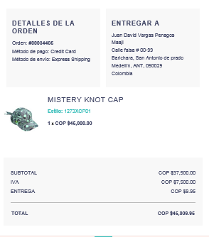

4). emailComponent - ‘newsletter-footer’ -> Content Asset – ‘newsletter-footer’



5. Order dispatched/unable to fulfil email🡪 Email Template: dispatchedOrderEmail

Subject line: Your order is on its way

1). ‘newsletter-header’ – Contains logo

Imagen que contiene objeto

Descripción generada con confianza alta

2). ‘dispatched-email-content-msg’

C:\Users\Dinu\AppData\Local\Microsoft\Windows\INetCache\Content.Word\onthis-way.png

Dear [First Name], your order has been shipped and on its way!

C:\Users\Vibin\AppData\Local\Microsoft\Windows\INetCache\Content.Word\order-detail.png

3) Custom object emailComponent: ‘order-details’ 🡪email template: email\_module/orderconfirmation

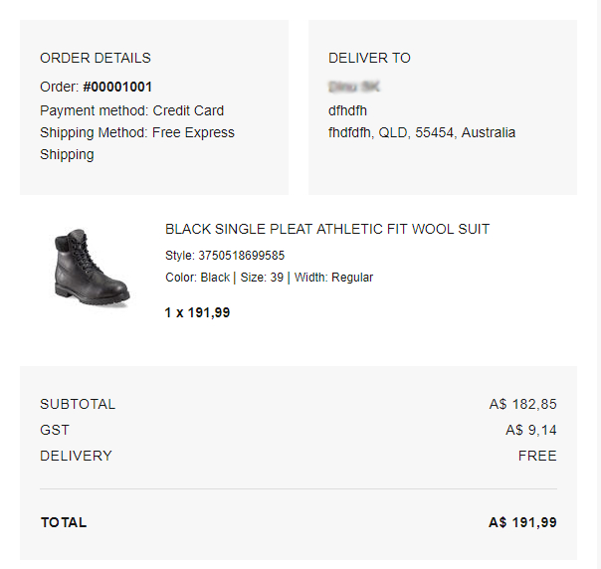

4). emailComponent - ‘newsletter-footer’ -> Content Asset – ‘newsletter-footer’



6. Order cancellation email🡪 Email Template: cancelledOrderEmail

Subject line: Your order has been cancelled

1). ‘newsletter-header’ – Contains logo

C:\Users\Dinu\AppData\Local\Microsoft\Windows\INetCache\Content.Word\seafolly-logo-email.png

2). ‘cancelled-email-content-msg’

Dear [First Name], Unfortunately we haven’t been able to process your order on this occasion. Order [INSERT ORDER NUMBER] has been cancelled and no payment has been taken from your account.

3) Custom object emailComponent: ‘order-details’ 🡪 email template: email\_module/orderconfirmation

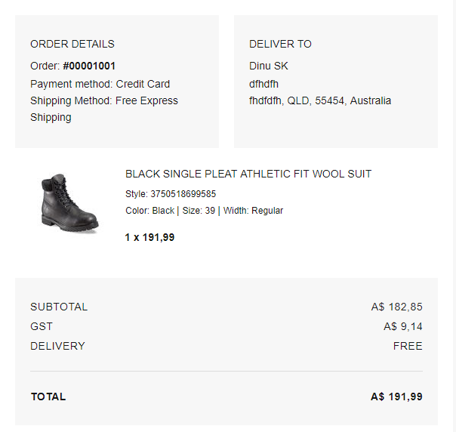

4). emailComponent - ‘newsletter-footer’ -> Content Asset – ‘newsletter-footer’



7. Order returned email🡪 Email Template: orderReturnedEmail

Subject line: We’ve received your return

1). ‘newsletter-header’ – Contains logo

C:\Users\Dinu\AppData\Local\Microsoft\Windows\INetCache\Content.Word\seafolly-logo-email.png

2). emailComponent - ‘returned-order-message-content’ -> Content Asset – ‘returned-order-message-content’

C:\Users\Vibin\AppData\Local\Microsoft\Windows\INetCache\Content.Word\order-refund.png

Hi [First Name], your refund has been processed. Please allow up to five business days for this to reflect in your account.

C:\Users\Vibin\AppData\Local\Microsoft\Windows\INetCache\Content.Word\order-detail.png

3) Custom object emailComponent: ‘orderreturnrequest ‘ 🡪 email template: email\_module/ returnordermail

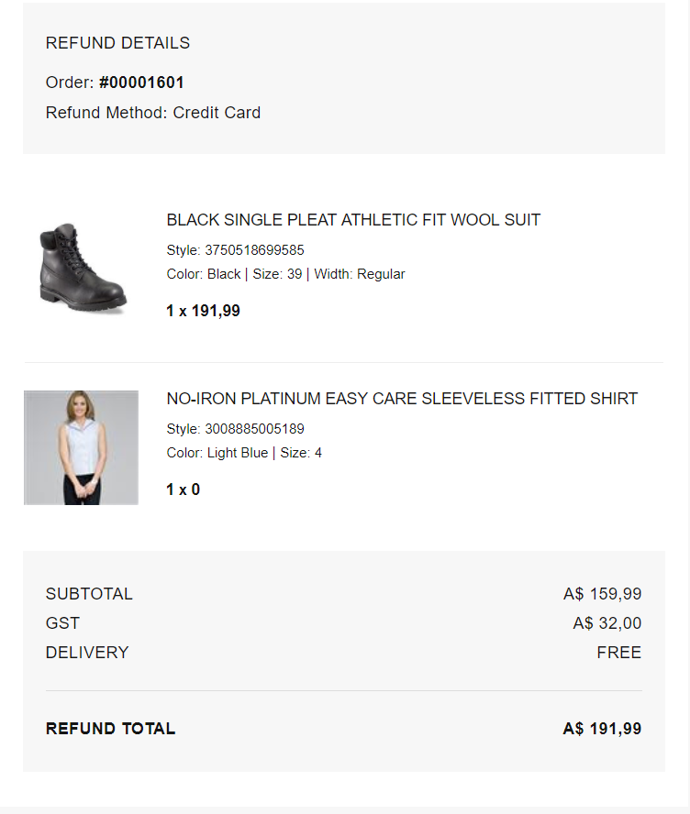

4). emailComponent - ‘newsletter-footer’ 🡪 Content Asset – ‘newsletter-footer’

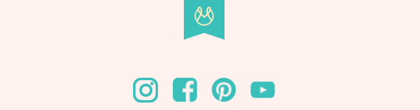

8. Forgot password email🡪 Email Template: resetPassword

Subject line: Forgotten your password?

1). emailComponent - ‘newsletter-header’ – Contains logo

Imagen que contiene objeto

Descripción generada con confianza alta

2). emailComponent - ‘resetpassword-newsletter-body’ 🡪 Content Asset – ‘resetpassword-newsletter-body’

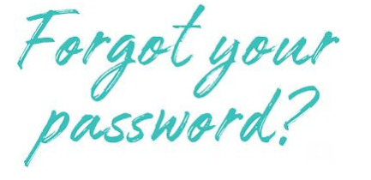

That’s okay, it happens! Click on the button below to reset your password.

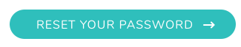

3). emailComponent - ‘newsletter-footer’ 🡪 Content Asset – ‘newsletter-footer’



9. New password confirmation email (after password reset) 🡪 Email Template: passwordResetSuccess

Subject line: Your Maaji password has been reset

1). ‘newsletter-header’ – Contains logo

Imagen que contiene objeto

Descripción generada con confianza alta

2). ‘pass-reset-succ-body’

Dear [First Name]

You’ve successfully reset the password for your Sunburn account.

* Update your personal information
* View your order history
* Add addresses (for a faster checkout experience)
* View and add items to your wish list
* Manage your newsletter subscription preferences

3). emailComponent - ‘newsletter-footer’ 🡪 Content Asset – ‘newsletter-footer’



10. Email with purchased e-gift card details: Email component = ‘giftCardEmail’

Subject line: A gift from [NAME]!

1). emailComponent - ‘newsletter-header’ – Contains logo

Imagen que contiene objeto

Descripción generada con confianza alta

2). emailComponent – ‘gift-purchase-email-content’ 🡪 Content Asset – ‘gift-purchase-email-content’

Hi [Recipient Full Name], you've just received a Maaji Gift Card from someone special. They must like you as much as we do!

C:\Users\Vibin\AppData\Local\Microsoft\Windows\INetCache\Content.Word\btn_shop_now_sf.png

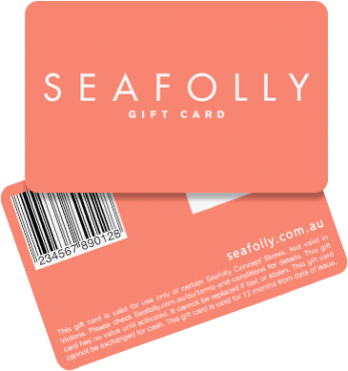

3). emailComponent - ‘gift-purchase-voucher-content’ 🡪 Template – ‘gift-purchase-voucher-content’

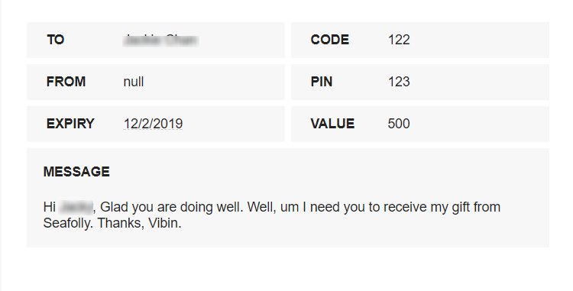

4). emailComponent - ‘newsletter-contact-us’ 🡪 Content Asset – ‘newsletter-contact-us’

Redeem this gift card online at www.seafolly.com.au or at an Australian Seafolly Concept store, click here to locate your nearest store. This gift card cannot be redeemed at Seafolly Melbourne Central, Seafolly stockist or outside of Australia. This gift card is in Australian Dollar (AUD) and cannot be exchanged for cash. Full Terms and Conditions can be found on our website www.seafolly.com.au/terms-and-conditions

Contact us on 1300 420 811 (+61 2 9291 8309) or at shop@seafolly.com.au

5). emailComponent - ‘newsletter-footer’ 🡪 Content Asset – ‘newsletter-footer’

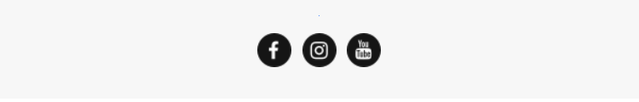

11. Email with returned e-gift card details: Email component = ‘giftCardEmail’

Subject Line: Refunded Gift Card

1). emailComponent - ‘newsletter-header’ – Contains logo

C:\Users\Vibin\AppData\Local\Microsoft\Windows\INetCache\Content.Word\seafolly-logo-email.png

2). emailComponent – ‘gift-refunded-email-content’ 🡪 Content Asset – ‘gift-refunded-email-content’



Hi [First Name], thank you for your return. We have successfully refunded this amount onto your new gift card below. Any remaining balance on your old card will still be available to use with the original code and pin.

C:\Users\Vibin\AppData\Local\Microsoft\Windows\INetCache\Content.Word\btn_shop_now_sf.png



3). emailComponent - ‘newsletter-contact-us’ 🡪 Content Asset – ‘newsletter-contact-us’

Redeem this gift card online at www.seafolly.com.au or at an Australian Seafolly Concept store, click here to locate your nearest store. This gift card cannot be redeemed at Seafolly Melbourne Central, Seafolly stockist or outside of Australia. This gift card is in Australian Dollar (AUD) and cannot be exchanged for cash. Full Terms and Conditions can be found on our website www.seafolly.com.au/terms-and-conditions

Contact us on 1300 420 811 (+61 2 9291 8309) or at shop@seafolly.com.au

4). emailComponent - ‘newsletter-footer’ 🡪 Content Asset – ‘newsletter-footer’

